Computer Language Coding Concepts

Assignment
When you program a system, you as the programmer can assign values to objects and set references to objects. But commands can also automatically assign values and set references to objects. To assign a value or reference, a special system command is called: an assignment command. Assignment commands take two parameters: the source and the target of the assignment. The source is the value or object. It is assigned to the target object or target reference. The source is an input parameter for the assignment command. The target is an output parameter.

An assignment is actually a combination of a Get and a Set call. Instead of using a call to an assignment command, you could also use a call to the Get and Set system commands. Because it is more intuitive to use a single assignment call, instead of a separate Get and a Set call, and assignment is so fundamental, there are assignment commands. Knowing how to use Get and Set commands, instead of a single assignment call, gives you a low-level understanding of assignment. This low-level understanding is important in order to create alternative forms of assignment, as explained in the article Alternative Assignments.

Each type of assignment has its own article:

- Value Assignment
- Object Assignment
- Class Assignment
- Interface Assignment
- Object Reference Assignment
- Object Reference Object Assignment
- Object Reference Class Assignment
- Object Reference Interface Assignment
- Alternative Assignments

See also:
Assignment in a Diagram,
Value Assignment,
Object Assignment,
Class Assignment,
Interface Assignment,
Object Reference Assignment,
Object Reference Object Assignment,
Object Reference Class Assignment,
Object Reference Interface Assignment,
Alternative Assignments

Author & Copyright: Jan-Joost van Zon Date: May 25, 2008 – July 28, 2008 Location: Oosterhout, The Netherlands Status: Finished

Ideas
Assignment,
2008-07-03

Een reference to reference maakt een object assignment zeg maar statisch???
En andersom: een object assignment kan worden vervangen door een verwijzing naar een verwijzing van een object?

En een value assignment dan? Kan dat worden vervangen door een verwijzing naar een verwijzing? Nee de gekopieerde waarde leeft daarna onafhankelijk voort.

Een class assignment is ook een reference to reference.
Hoe kunnen deze twee dingen zo inwisselbaar zijn?
Iets statisch (een reference to reference) en een actie (een object assignment).

JJ

Computer Language Coding Principles,
2008-07-04

An object assignment, and a pointer to a pointer are not completely interchangable, but it is close to it.

JJ

Assignment,
Pointers to pointers as a concept,
2008-08

A related item can point to a →1 related item contained by another parent or to a →n related list item contained by another parent. Redirecting to another related item or related list item may be accomplished by extending the object get and object set procedures of the related item. The extension procedure basically constitutes, or instantiates, the redirection. So a pointer to a pointer would be accomplished by procedure extension, instead of implementing it in the code base. However, this will not work for related list items, because all items in a related list have the same decoration, and redirecting a list item to an arbitrary other related item or related list item would require each list item to have its own decoration.

< If you make a related item return an object out of another parent, then this decoration with procedures is functionally the same as making the related item a pointer to related item in another parent. But this implementation of a pointer to a pointer will not work for related list items, because list items do not have their own individual decoration with prorcedures, so that’s why pointers to pointers still need to be part of the code base. >

JJ

Integrate these sections

Value Direction
Read-write direction is something so basic in computer language, that it has a separate line type. Value direction is indicated by a wavy line.

A value connection is actually not a real connection between symbols, but a value assignment.

A wavy line is actually a good symbol for it, because it looks like a less direct connection than the other line types. The wavy line looks like a less direct connection, because the complete length of the line, curves and everything, is much longer than a straight line. A wavy line also indicates heat, or activity, more than the other line types. Value direction is an action.

Read-write direction, input-output direction and value direction are synonymous terms.

A read of an output parameter is always accompanied by a write to another object. A write to an input parameter is always preceded by a read from another object. A read operation is always accompanied by a write operation. A value is read from one object, only to be written to another object.

> Actually, writing is not the only purpose a read can have. You can also read for access, apart from read for assignment, but this will be thought through later.

Clone
For more complex objects, value direction can mean an object will be cloned up until a certain cloning depth. When the values of an object are cloned up until a certain depth, no references to original objects will be taken over by the clone. Clones like that never have references to existing objects, but always contain entirely new objects or object references that are Nothing.

A single-value transfer is actually the equivalent of a cloning operation with a depth of 1.

There are other types of cloning in which clones do end up with reference to existing objects, but those types of cloning will be covered in the article Clone in the Editing Concepts.

These are examples diagram expressions of Value cloning operations:

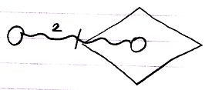

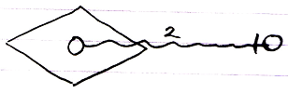

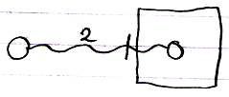

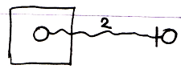

The number 2 stands for the cloning depth.
The access mark indicates value direction.

A single-value transfer will be the same as a cloning depth of 1, but the number 1 will not be shown then.

Here are examples of expression of value cloning access connectors:

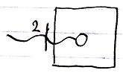

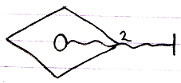

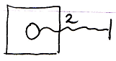

More Ideas
Assignment,
2008-08

A reference parameter is assigned an object.



The assignment of an object can also be replaced with the redirection of an object.

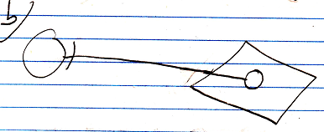

Parameter passing in text code with an object assignment call in it:

A ( O o= B ( ) . O )

Command A is called, and its Reference In parameter O is assigned the output O of the command B. So no temporary variable is needed to first pick up the output of B and then assign it as input of command A.

JJ

From the original Symbol documentation

Assignment
Before I explain using arguments, I must introduce another basic concept: assignment. I have to explain it, because to use input arguments you have to assign a values to it. Likewise, to retain output arguments, you must assign the output values to other objects.

An assignment:

A = B

consists of two actions: a Get and a Set. First you Get B. Then you Set A. An assignment always consists of one Get, immediately followed by one Set.

There are two main types of assignment: state assignment and line assignment.

State assignment is the most basic, and the easiest to understand. The values of one object are copied to another.

A = B

The value of B is copied to A. The state assignment does not make A and B the same object. They are two separate objects that contain equal values. Change the value of one object and the two objects differ again.

To make A and B represent the same object, you have to do a line assignment:

A B

Pronounce: A’s object is B
It’s an equals sign with the letter o in it.

This is an object line assignment. The object line of A is set to symbol B. The result is that A points to B.

The operator = is not reserved for state assignment. Instead, the operator for state assignment is commonly: .

A simple diagram notation of an assignment is as follows:

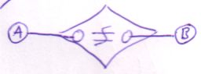  State assigment | 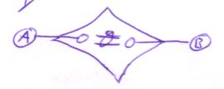  Object assignment

Or:

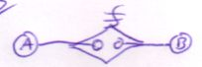  State assigment | 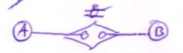  Object assignment

The result of object assignment:

is:

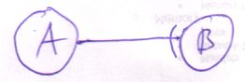

But you can also view it the other way around. The following:

Is the result of an object assignment:

This is an important way of viewing it, because most of the times you’ll only see the result of an assignment and not the assignment operation itself. The assignment operation is there, however. Therefore an even simpler notation of assignment is not to show the assignment at all.

Unfortunately, the result of state assignment is not visible in diagram code as a line, so you have to display the explicit assignment.

A shorthand, quick notation of an assignment is the following:

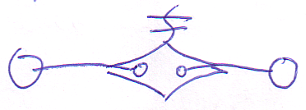 | = | 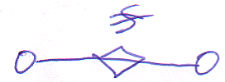

There are more ways to draw out an assignment, but the ones here are by far the simplest and most easy to understand. Other notations are covered in another chapter.

State assignment is the most basic assignment. Line assignment is based on it. A line target is stored in an Integer object. So when assigning the line target, you’re actually assigning the State of this Integer object. Drawing a line assignment as a state assignment is a more difficult, but useful notation. However, in this chapter I will stick to the simpler notations.

You can work with the type and interface lines the same way: there’s also type assignment and interface assignment. Likewise, you can work with line assignments for procedure symbols. However, I’ll mostly talk about state and object assignment.

Distinguishing Assignment Source and Target
There’s one more ambiguity in argument access that I will resolve here. In an assignment call in diagram as follows:

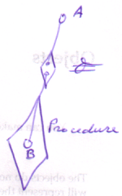

there isn’t anything that tells which is the source of the assignment and which is the target: is it Procedure . B A or is it A Procedure . B ? You could name the arguments of the (object is) call: name them Get and Set to make out the difference, but usually another method is adopted.

Assuming the assignment is really Procedure . B A, the effect of the assignment is:

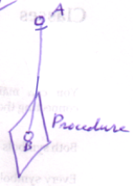

To show the ‘direction’ of the assignment, the access symbol of the resulting line is shown in the assignment call:



In this case, the access symbol is about the effect of the assignment, not about the direction of ’s Set argument.

In the case of state assignment, the result is not a line, so logically the state assignment call can’t ‘borrow’ the access symbol from the resultant line. However, in line assignment, the target of the line, the source of the assignment (!), gets the access symbol. Conversely, the source of the state assignment gets an access symbol:

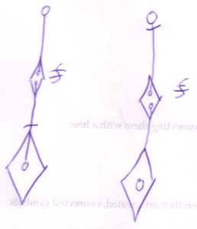

The rule is: the source of the assignment gets the access symbol. An oddity is that the source of a line assignment is the target of the resultant line.

Direction can be determined by assumption of the most common situation. Therefore, the access symbol can be left out it the resultant line is outwards.

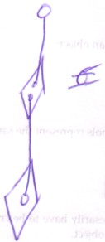 | 

For state assignments it’s adised to always show the access symbol.

Executions & Parameters

Brainstorm

Summary of Old Subdivision

- Basics of assignment
  - Line assignment
  - State assignment
  - The notation I'll use here

- State assignment is the basic assignment

New Subdivision
- Assignment
  - The terms Get and Set, introduce them
  - A Get and Set combine to an assignment
  - Line assignment
  - State assignment
  - Use the simple notation
  - ~ State assignment is the basic assignment

